Kinetic Display Assembly Instructions

jbeman@hotmail.com

# Introduction

Complete the assembly of the printed circuit boards (PCB) and electric motor wire soldering.

# Tools

* 3D printer
* Wire Stripper for 28 AWG stranded wire
* Small Philips head screwdriver
* Dupont connector tool
* Soldering station with solder/flux
* Needle nose pliers
* Tweezers
* Clamping tweezers
* Zinc strip or thin metal strip (for melting PLA)
* Wire snipper
* Multimeter
* Breadboard and jumpers for testing electronics
* Label maker (optional)
* Computer with USB connector

# Software

* VS Code
* Micropython

# Bill of materials

|  |  |
| --- | --- |
| Item | Quantity |
| Digit 0,2,3 PCB | 3 |
| Digit 1 PCB | 1 |
| Powerbank PCB | 1 |
| A4 Size Felt Sheets with Adhesive Backing | 3 |
| 2 Inch Jumbo Paper Clips (Smooth Big Paperclips) | 20 |
| M2 x 6mm Stainless Steel Phillips Round Head Self Tapping Screws | 200 |
| M2 x 8mm Stainless Steel Phillips Round Head Self Tapping Screws | 200 |
| M2 X 15mm Stainless Steel Phillips Round Head Self Tapping Screws | 50 |
| Micro 130 DC Motor Strong Magnetic Brushed Electric DC 3V -12V 25000 RPM Cars Toys Electric Motor, High Speed Torque DIY | 30 |
| 28 AWG Gauge Flexible Silicone Rubber Electric Wire 6 Colors 32.8 feet each | 1 |
| Dupont Jumper Wire Cable Female Pin Connector 2.54mm | 100 |
| 2.54mm 1x2p Dupont Connector Housing Female for Dupont Cable and Jumper Wire | 100 |
| Digital Temperature and Humidity Sensor DHT11 LED Module, 3 pin | 1 |
| 5mm 0.5 Ω ohm Photoresistor LDR Resistor 5516 GL5516 Light-Dependent Photoconductor (Photo Light Sensitive) | 1 |
| 5mm Flat Top LED Diode Lights (Clear Transparent Lens) Bright Lighting Bulb Lamps Electronics Components Indicator Light Emitting Diodes | 114 |
| Vertical Slide Switches Micro High Knob 3 Pin 2 Position 1P2T SPDT Panel Mount AC 125V 2A | 1 |
| 2.54mm 0.1" Pitch PCB Mount Screw Terminal Block Connector, 2P 3P 4P Terminals 150V 6A for 26-18AWG Cable | 1 |
| LM2596 DC-DC Step Down Variable Volt Regulator Input 3.2V-40V Output 1.25V-35V Adjustable Buck Converter Electronic Voltage Stabilizer Power Supply Module | 5 |
| 2.1mm Barrel Jack 5.5x2.1mm Female DC Power Jack 2.1 X 5.5mm DC Jack Connector 6V 9V 12V DC Jack Panel Mount | 1 |
| 12V 5A Power Supply, Waysse Power Supply Adapter, AC DC Converter 100-220V to 12 Volt 5 Amp Transformer 5.5x2.1mm Plug | 1 |
| S8050D S8050 NPN Transistor TO-92 20V 700MA 1W | 1 |
| 1N4001 Diode, standard, 1A, 50V, DO-41 | 1 |
| (optional) 20pin x 10pcs Female Headers Pins Straight Single Row Gold Plated Pitch 2.54mm 0.1 inch for PCB Connector Machine Breadboard Electronic Circuit Board | 10 |
| SONGLE SRS-05VDC-SL 05VDC-SL 4100 Blue 5V 6PIN Power Relay Original | 1 |
| L293D 16-pin IC Stepper Motor Drivers Controller | 17 |
| 0.1uF Ceramic Disc Capacitor - 50 Volts | 5 |
| 1uF Electrolytic Capacitor 1UF-50V-5X11 | 5 |
| SS8550 TO-92 PNP Transistor | 1 |
| 2N2222 TO-92 - NPN Transistor | 1 |
| 10K ohm Resistor 1/2w (0.5Watt) ±1% Tolerance Metal Film Fixed Resistor | 2 |
| Vertical Slide Switch Micro High Knob 3 Pin 2 Position 1P2T SPDT Panel Mount AC 125V 2A | 1 |
| Raspberry pi 2040 pico | 4 |
| Raspberry pi 2040 pico-W | 1 |
| Superglue (small tube) | 1 |

# Test and solder components onto the PCBs

# Face assembly

Print the display faces following the table of fused deposition modeling (FDM) settings below and press the two pieces together as diagrammed in figure 1.

Table 1. Display Face FDM settings

|  |  |  |
| --- | --- | --- |
| File Name | face-digit0-1.stl | face-digits2-3.stl |
| Description | Right side of display face  (when viewed from front) | Left side of display face  (when viewed from front) |
| Material | PLA | PLA |
| Color | White | White |
| Size | 1.75mm | 1.75mm |
| Temp (C) | 190-210 | 190-210 |
| Quantity | 1 | 1 |
| Per unit (g) | 340 | 315 |
| Plate | Smooth | Smooth |
| Layer Height | 0.2 mm | 0.2 mm |
| Infill | 50% | 50% |
| Infill Pattern | Grid | Grid |
| Enable Support | Yes | Yes |
| Ironing | Top Surfaces | Top Surfaces |

Below are few guidelines to keep in mind when printing and assembling the display face:

* The display face uses over 2/3rds of the 1 KG roll of filament. Therefore, be sure to use the same roll of filament when printing both halves of the display face. Also, have two 1 KG rolls of white filament from the same batch to avoid inconsistencies in your print color.
* The infill should be 50% or greater to avoid light leaching from the segment LEDs or from the backside of the display face. I suggest you use a grid infill pattern only for speed and efficiency. The type of infill pattern is at your discretion.
* Don’t use any glue as it isn’t necessary and may make a mess.
* Don’t worry if your 3D printer and slicer can’t iron the top surfaces. Ironing the top surfaces is for fit and finish and won’t affect the functionality of the display.
* Make sure you apply an adhesive to the printer plate bed otherwise the edges and corners of the display face may warp. I used all weather Aqua Net, super hold hair spray for my display faces which provided an even coating of adhesive across the entire surface of the bed plate and resulted in nearly perfect corners and edges.

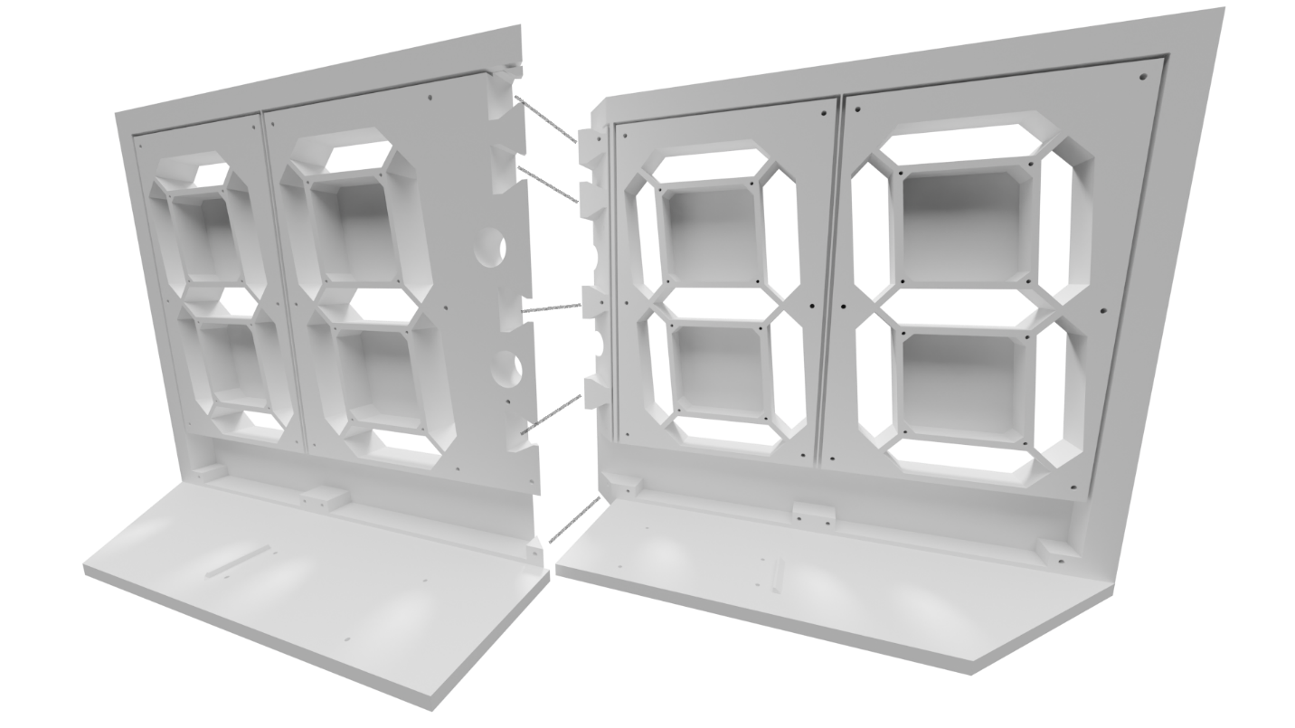

Figure 1. Back view of the display face

* From the back view of the display face, the left face piece (from left to right) are digits 0, 1 followed by the colons. The right face piece (from left to right) are digits 2 and 3. When viewing the assembled display face from the back, digit 0 is the left-most digit whereas digit 3 is the right-most digit. Consider adding a label above each digit.
* To prevent unwanted warping of the face, allow the display face to thoroughly cool (about 30 minutes after completion) before removing it from the printer.

# Gasket and Digit PCBs Assembly

Print the gaskets and assemble with the PCBs using M1.7x8mm self-tapping screws. Each digit PCB will have two, 28 AWG stranded wires that need to be long enough to reach its corresponding buck converter.

Table 2. Digit gaskets FDM settings

|  |  |  |
| --- | --- | --- |
| File Name | digit-colon-gasket.stl | digit-gasket.stl |
| Description | Colon/Digit PCB gasket | Digit PCB gasket |
| Material | TPU | TPU |
| Color | Black | Black |
| Size | 1.75mm | 1.75mm |
| Temp (C) | 190-210 | 190-210 |
| Quantity | 1 | 3 |
| Per unit (g) | 39 | 20 |
| Total (g) | 39 | 60 |
| Brand | Colorful (Flexible) | Colorful (Flexible) |
| Plate | Smooth | Smooth |
| Layer Height | 0.2 mm | 0.2 mm |
| Infill | 50% | 50% |
| Infill Pattern | Grid | Grid |
| Enable Support | No | No |
| Ironing | None | None |

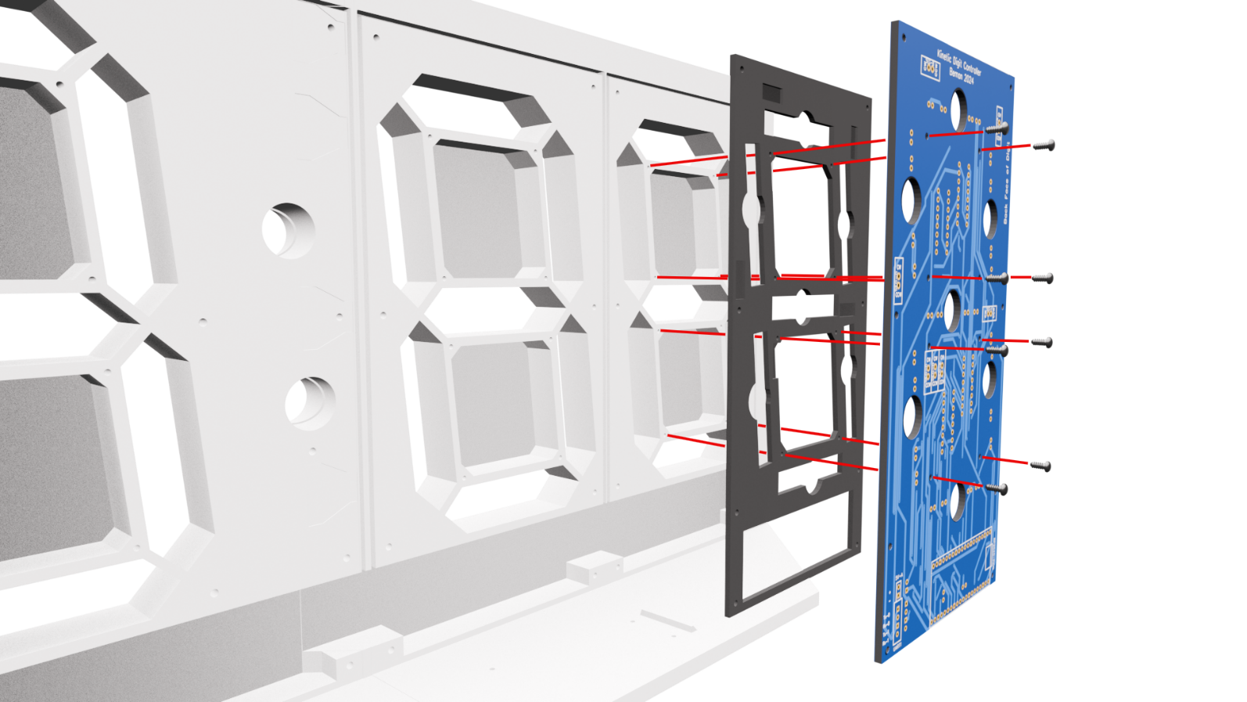

Figure 2. Add digit 0, 2, and 3 gaskets and the digit PCBs* to the back of display the face

*Note this diagram doesn’t display the PCB completed with the components soldered onto the board. At this stage you should have completed the soldering and testing of all components onto the PCBs.

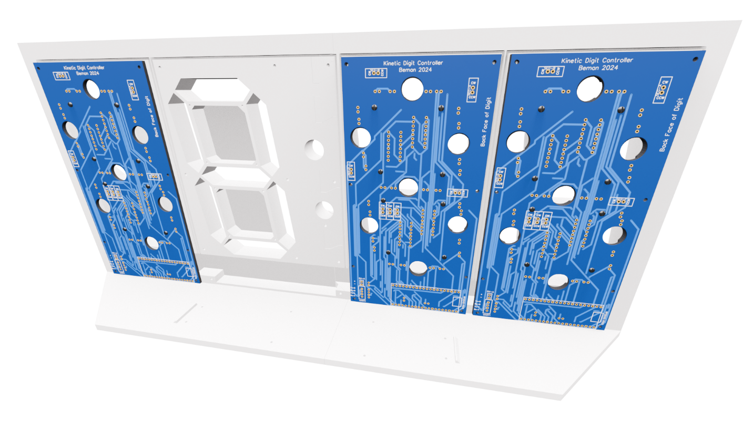

Figure 3. Back of the display showing assembled digits 0, 2, and 3 with gaskets

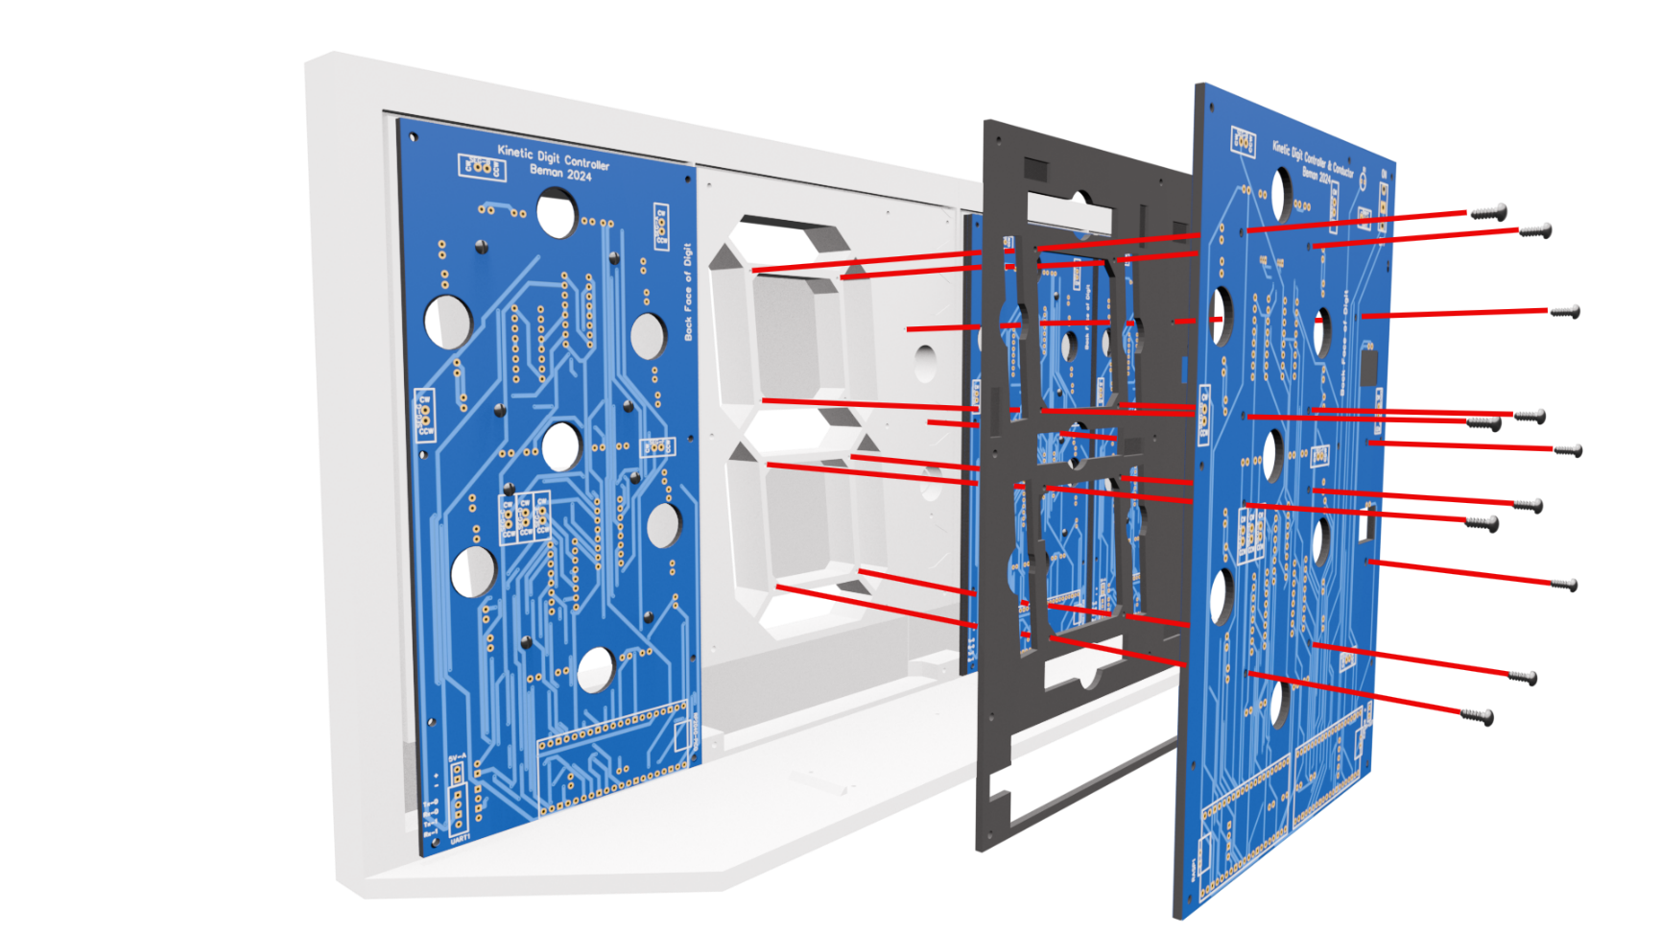

Figure 4. Back of the display showing the assembly of digit 1 and colons with gasket

# Actuator assembly

There are 30 actuators in the display, 7 per digit and 2 for the colons (4 digits x 7 segments + 2 colons = 30 total actuators). The diagrams below identify the various parts of each actuator. Take note that various parts of the actuator require differing types of FDM filament.

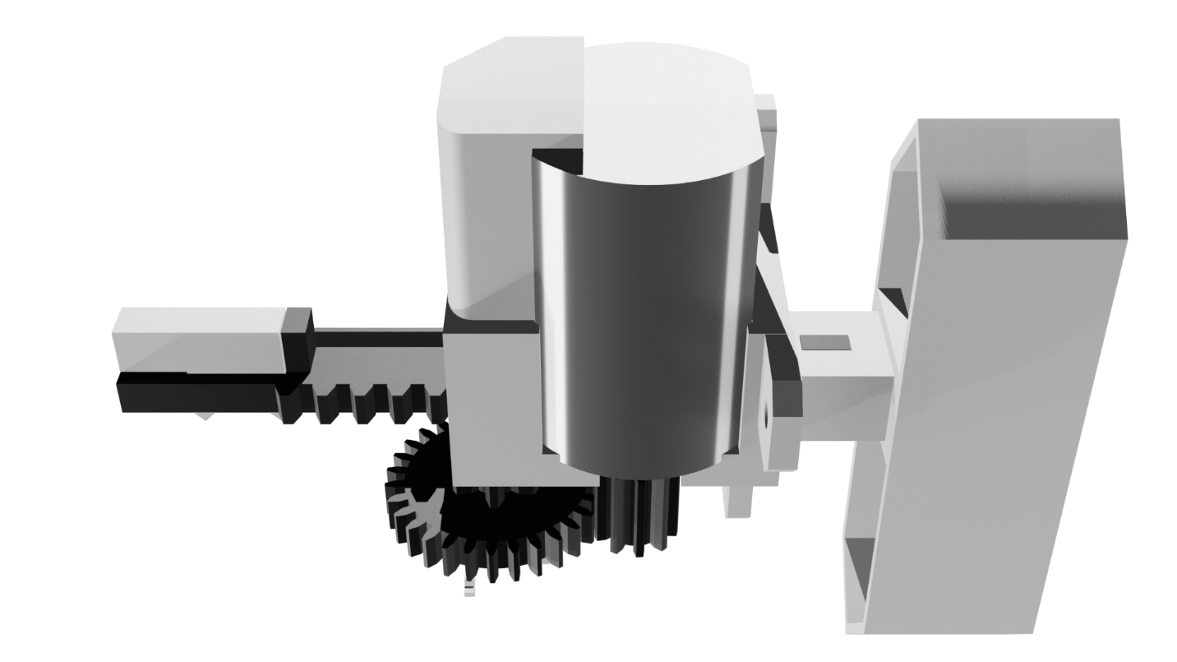

Figure 5. Fully assembled actuator with segment and back bumper.

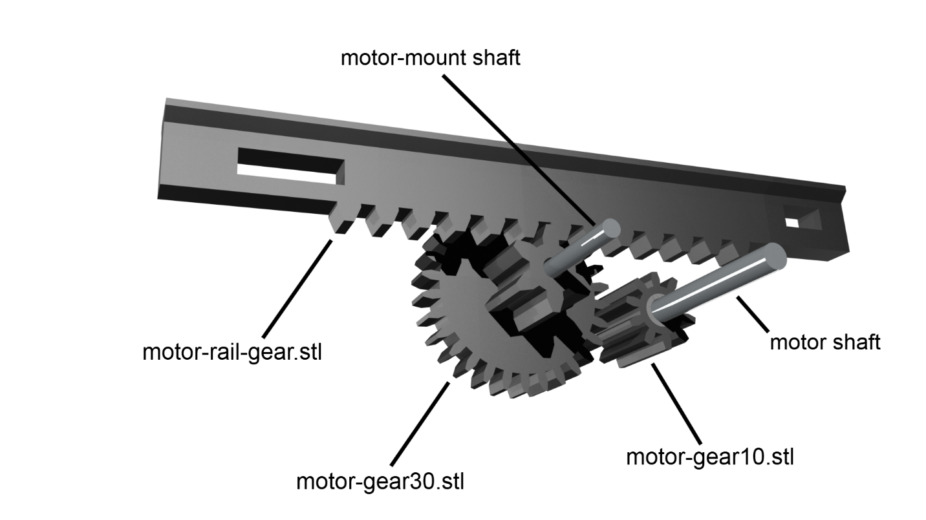

Figure 6. Actuator rack and pinion gear assembly

## Assembling the motor mount

Print 30 motor mounts and 30-toothed gears using the settings in the table below. Be sure to thoroughly dry the Nylon (PA) for 48 to 72 hours at 45° C before printing.

|  |  |  |
| --- | --- | --- |
| File Name | motor-gear30.stl | motor-mount.stl |
| Description | 3:1 reduction gear | Micro 130 DC 3V -12V motor mount |
| Material | Nylon (PA) | PLA |
| Color | Black | White |
| Size | 1.75mm | 1.75mm |
| Temp (C) | 245-260 | 190-210 |
| Quantity | 30 | 30 |
| Per unit (g) | 1.4 | 9.7 |
| Total (g) | 42 | 291 |
| Brand | Overture (Easy Nylon) | Comgrow |
| Plate | Smooth or glass | Smooth or glass |
| Layer Height | 0.2 mm | 0.2 mm |
| Infill | 100% | 50% |
| Infill Pattern | Rectilinear | Grid |
| Enable Support | No | No |
| Ironing | None | Top Surfaces |

Cut 30, 20mm shafts from the straight sections of large paper clips. Following the diagram below, discard the motor mount section in red.

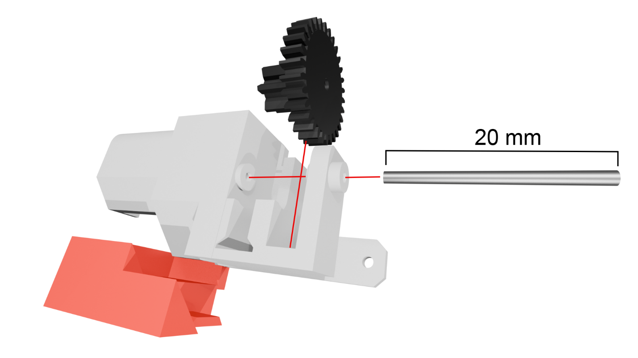

Figure 7. Motor mount assembly with 20mm shaft, the red support section is discarded

### Motor mount step-by-step assembly

|  |  |
| --- | --- |
| 1. Print the motor mount, 30 tooth gear, and cut a 20mm length of shaft from a large paper clip. | A plastic gear, motor mount, and metal shaft on a cutting mat |
| 1. Feed the shaft into the outer collar of the motor mount. Have about 0.5 mm protruding through the inside of the outer collar. | A close-up of the metal shaft being inserted into the motor mount |
| 1. Align the 30-tooth gear with the shaft, having the large gear facing out and the small gear on the inside. Slide the shaft all the way into the motor mount so that it countersinks into the outer collar. | Assembled motor mount on a cutting mat |
| 1. Heat up your soldering iron to 250ºC and melt the outer collar over the end of the shaft to prevent it from working out of the motor mount. | Preparing the assembled motor mount collar to be melted by a soldering iron |
| 1. The half-melted collar forms a permanent hold for the motor mount shaft and 30-tooth gear. Note that I melted the outer collar using a small zinc strip held by clamping tweezers. Once complete, the 30-tooth gear should move freely back and forth by pushing it with your finger but should not move side to side nor freely spin. | A fully assembled motor mount with the outer collar melted to held the metal shaft in place |

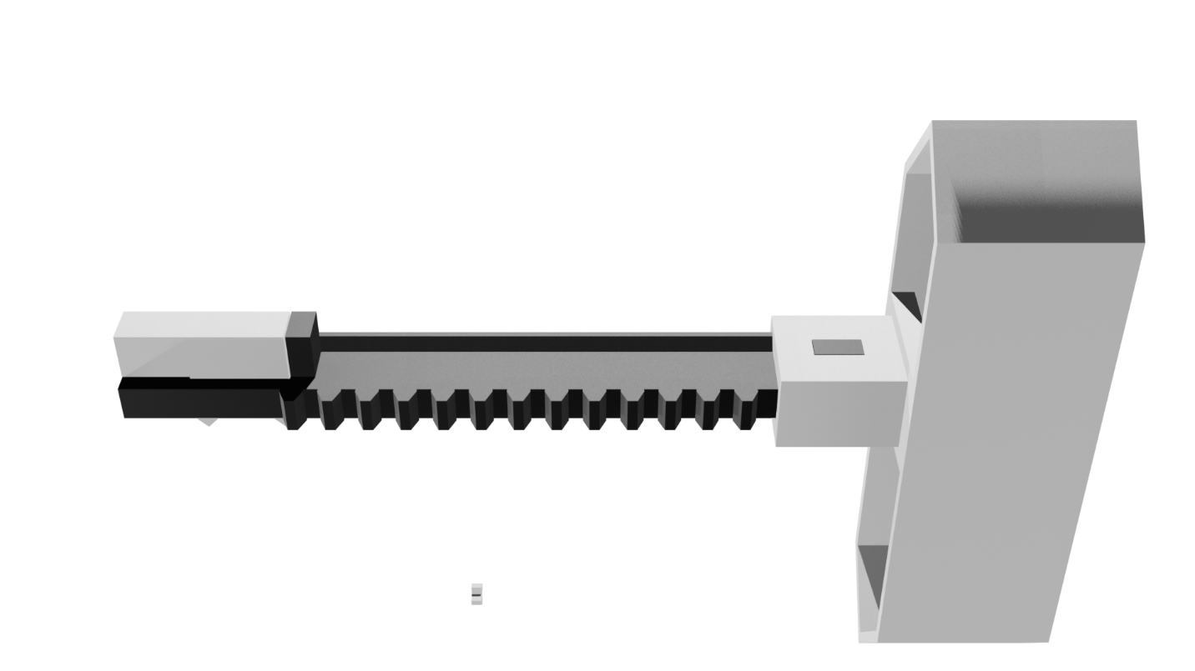

Prepare the Motors

# Schematics for Digits 0, 2 & 3

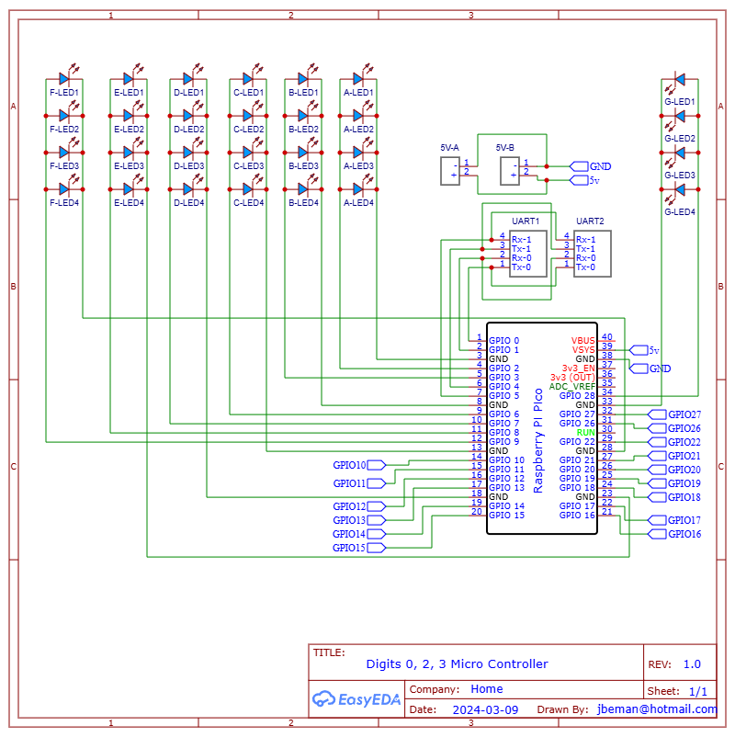

Figure 8. Schematic for Digits 0, 2, 3 Microcontrollers

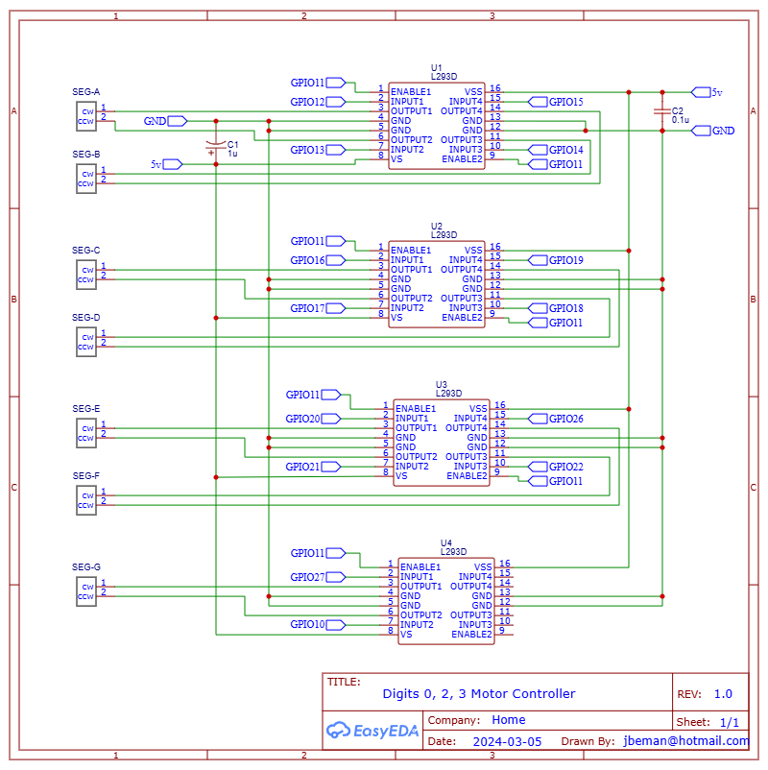

# PCB for Digits 0, 2, 3

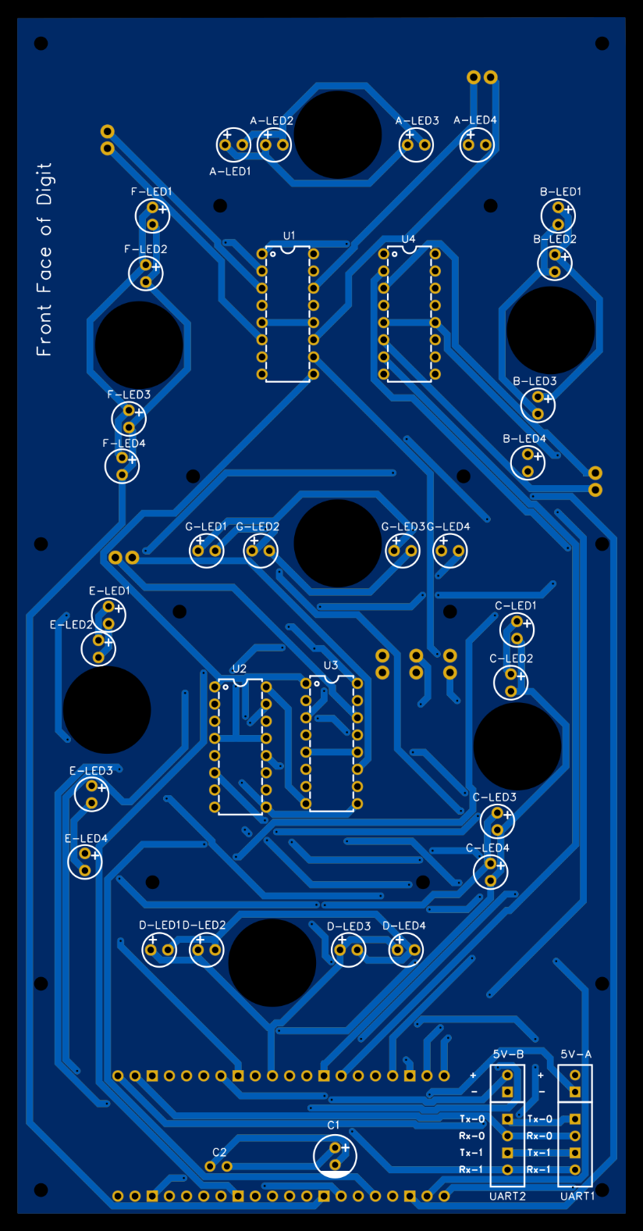

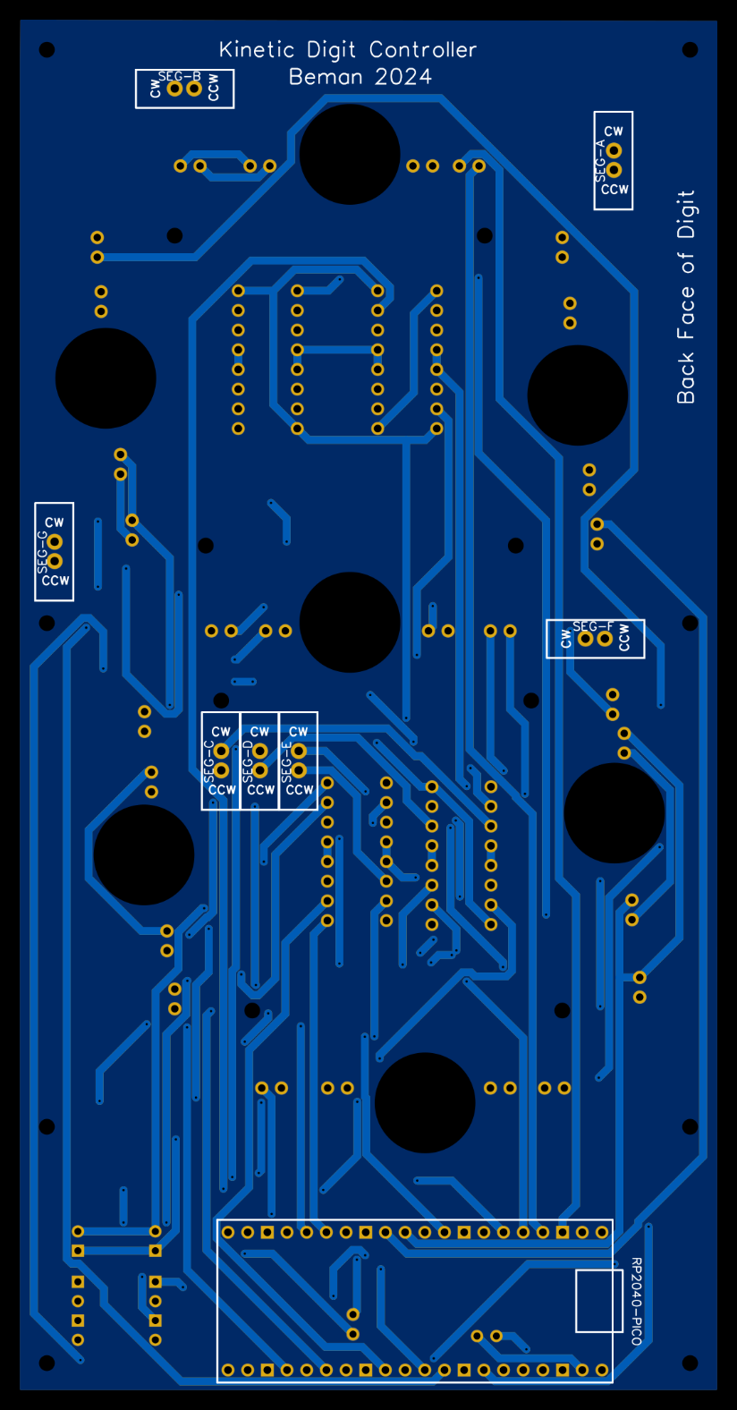

# Schematics for Digit 1 and Colons

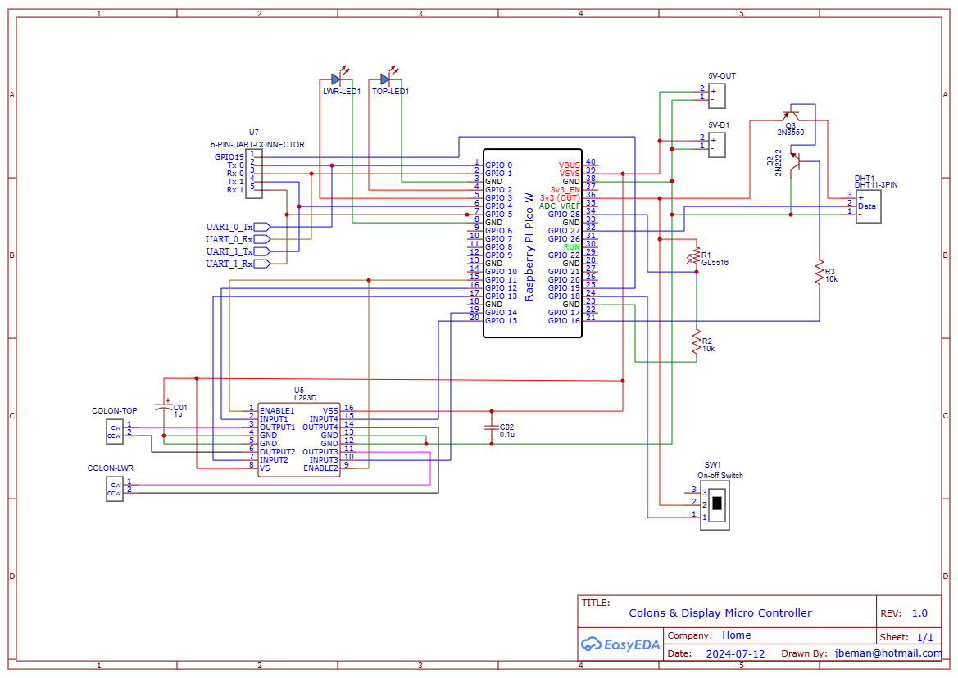

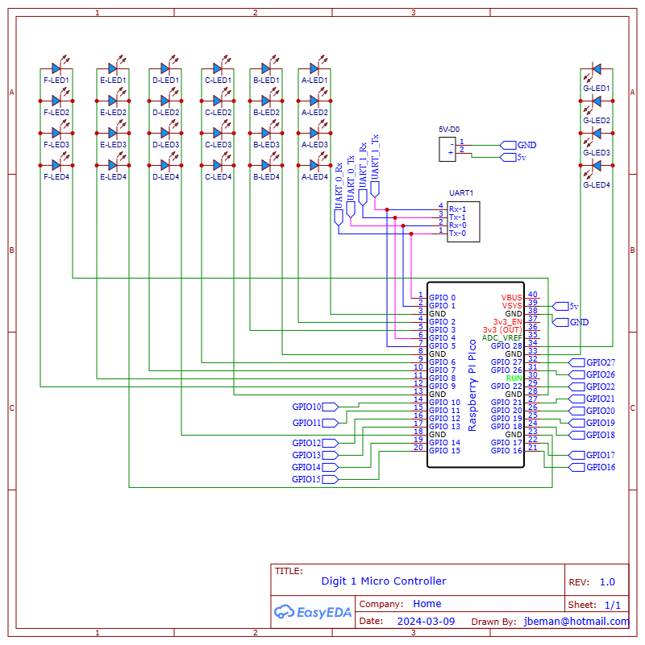

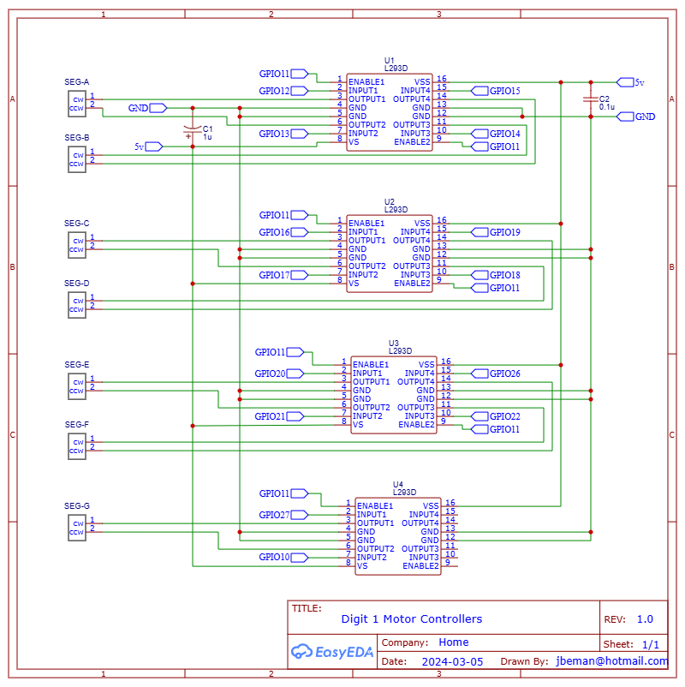

# PCB for Digit 1 & Colons

